**Title:** Protecting society from COVID-19 fake news pandemic through a fake/real news verification app (ChainFact) where (1) users will be rewarded to read news and (2) news accuracy will be validated by news media, gov, etc. through a blockchain-based voting system.

The COVID-19 fake news pandemic can be as deadly as controlling the coronavirus itself. Our team is proposing a fake/real news verification app (ChainFact) where (1) users will be rewarded with digital dollar to read news and (2) the accuracy of the news will be validated by numerous news media and even governments through a blockchain-based voting system.

**Summary:**

The COVID-19 fake news pandemic is as challenging to solve as the coronavirus itself. Dangerous misinformation circulating on social media, e.g. “drinking bleach will cure Covid-19” and “coronavirus is not heat-resistant - walking outside is enough to disinfect you”, runs the risk of harming individuals. Our team is proposing a blockchain-based fake/real news verification platform (ChainFact) where (1) users will be rewarded with digital dollar/currency to read real news and (2) the accuracy of the news will be validated by numerous news media and even governments through a blockchain-based voting system. This guarantees the transparency and accuracy of information and at the same time incentivizes people to read accurate news on our proposed ChainFact app/website over social media which is scattered with fake news.

With our team’s diverse background and MIT resources such as MIT Digital Currency Initiative (DCI), MIT Algorand blockchain, etc., this put us in a very strong position to tackle this COVID-19 fake news pandemic.

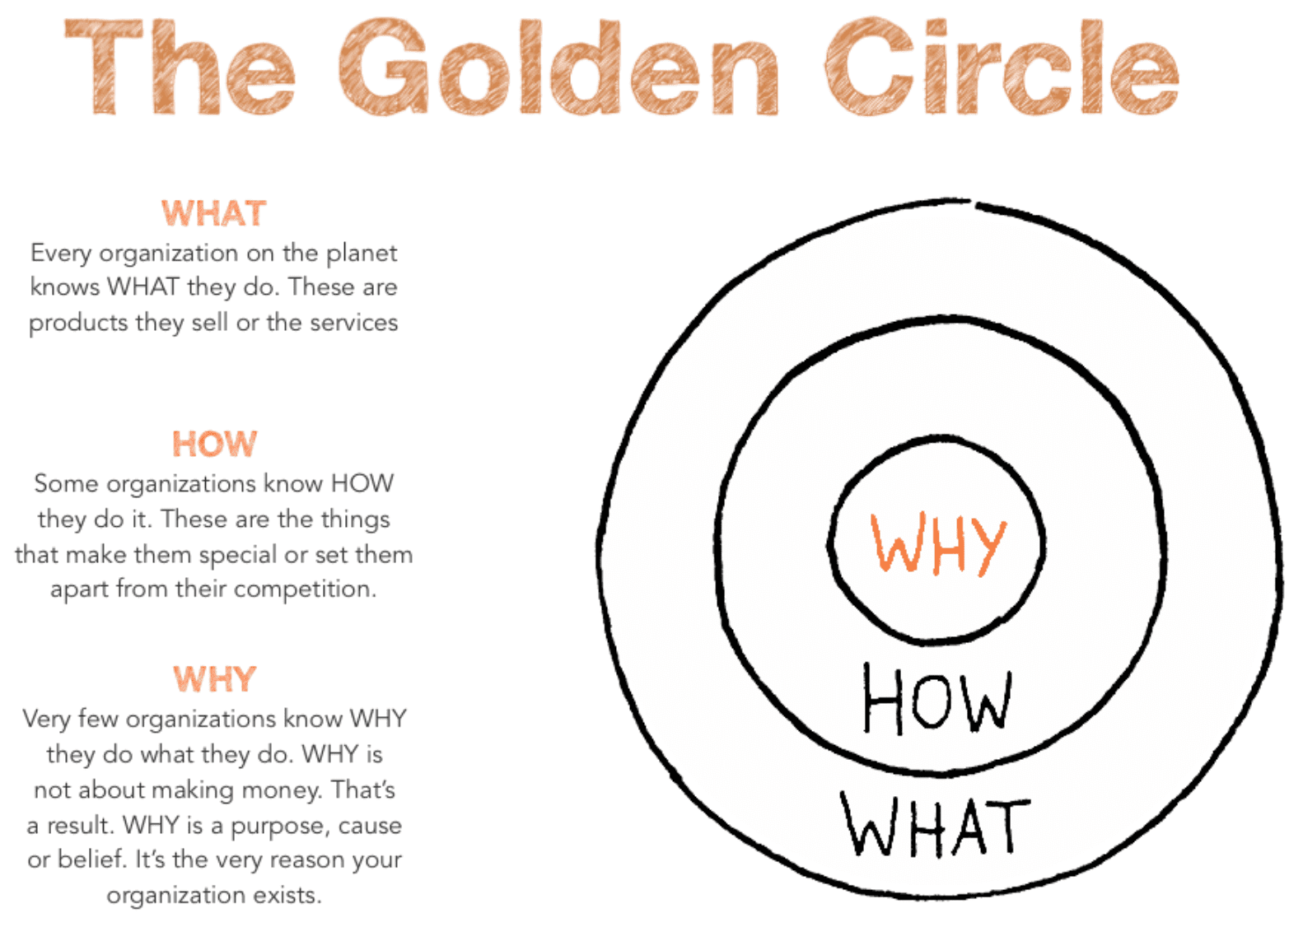

**NOTE: Keep thinking of WHAT, HOW, WHY while reading & writing**

**Write a one page summary of your part to me. And I’ll convert it into a slide.**

**Jothi: COVID19 Fake news**

1. Go through DonaldTrump twitter in the past 2 months. How many % of its covid19-related posts have to do with fake news?

What: What fake news are circulating on social media?

How: How these fake news cause harm to society? How on earth that Trump is calling CNN, New York Times scam?

Why: Why these fake news issue should be fixed asap?

**Tugsuu:**

**Stablecoin on Algorand**

What: What are needed to issue a stablecoin on Algorand?

How: How should it be implemented?

Why:

**Tay Loong and Chun Kee:**

**Reward Mechanism**

What: What reward system should ChainFact use? Note: We should use stablecoin.

How: How should the system reward users? How should users engage with the news?

Why:

What: What stats are there on Brave browser adoption? Is it successful?

How: How is it successful? How does it target its user base?

Why: Why do people like it?

<https://basicattentiontoken.org/>

**Mong Guo and Yon Sheng:**

**ChainFact app/website**

YS: Can you guys redraw our ChainFact logo using the same style?

MongGr: Can you find is there fake news verification app besides facebook? <https://www.facebook.com/help/1952307158131536>

